

QUANTITATIVE SCIENCES DEPARTMENT |  | 
Course: A2MAA
Topic Title: Skills Test 3
Student Name:_____________________________________ | Date: __________2015
Special Instructions: No calculator or notes | Time Allowed: 20 minutes
 | Marks: / 15

Question 1 [3 marks] Complete the addition pyramid below:

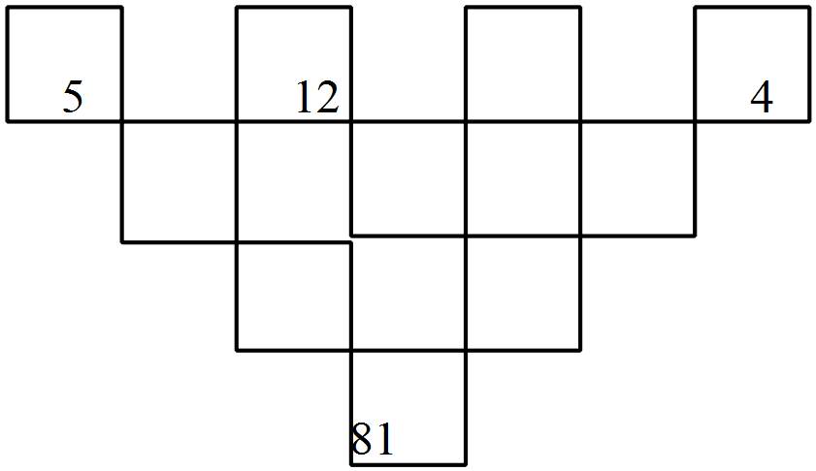

Question 2 [3 marks]
I think of a number, add three and multiply that answer by four. If the answer is 44 what number did I first think of?

Question 3 [3 marks]
I I think of a number, add sixteen and multiply the result by four. The answer is twenty four more than twenty times the number I first thought of. What was that number?

Question 4 [3 marks]
I think of a number, subtract it from forty, multiply the result by two and add the number I first thought of and ended up with 30 more than the number I first thought of. Find the number I first thought of.

Question 5 [3 marks] Dan is 27 years older than his daughter Liz. In 11 years time, Dan will be twice as old as Liz. How old is Liz now?

